Сайт: <https://www.booking.com/hotel/ua/bukovel-residence-15a.uk.html?aid=356980&label=gog235jc-1DCAMY_gMo6QFCB2J1a292ZWxIKVgDaOkBiAEBmAEpuAEXyAEM2AED6AEB-AECiAIBqAIDuAKBhuH0BcACAQ&sid=45bf826d02cbc0e0696af9f90c38ce59&lp_sr_snippet=1>

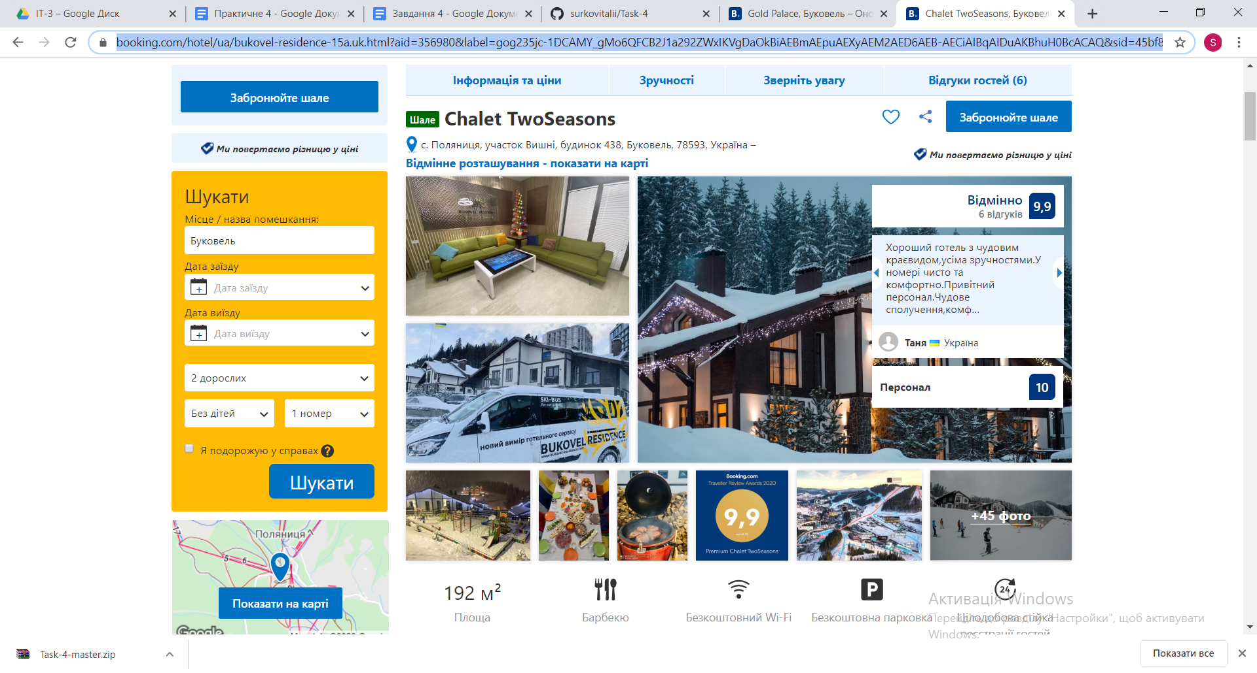

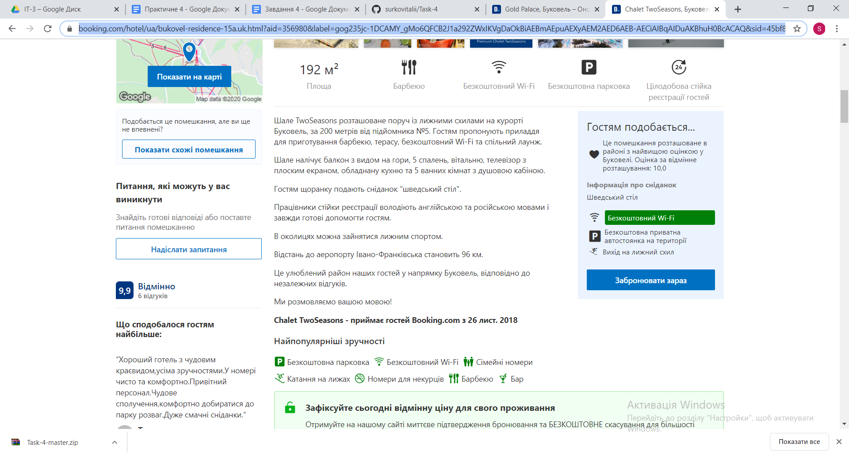

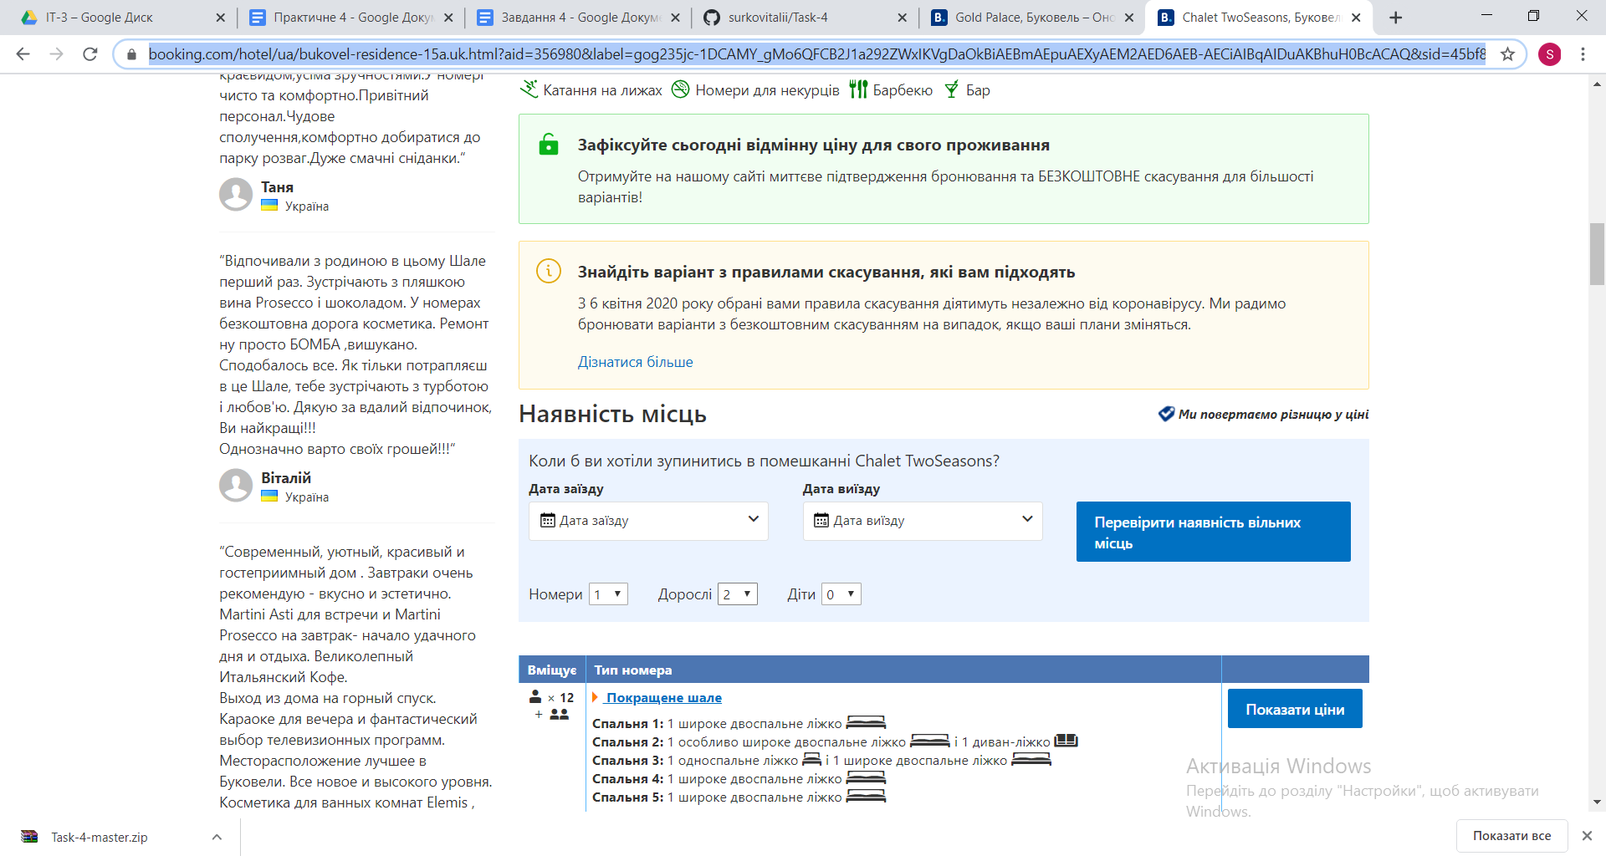

Запасний варіант: <https://www.booking.com/hotel/ua/gold-palace.uk.html?aid=331503&label=bukovel-O5eeOfHai_z4cPQAB%2A1XXwS26446003511%3Apl%3Ata%3Ap1%3Ap2%3Aac%3Aap%3Aneg%3Afi%3Atiaud-294080458506%3Akwd-328753461013%3Alp1012859%3Ali%3Adec%3Adm%3Appccp%3DUmFuZG9tSVYkc2RlIyh9YTQUGSsRwx9_VQ_bgBjtgSg&sid=45bf826d02cbc0e0696af9f90c38ce59&lp_sr_snippet=1>

